Full name: ___________________________________________ Class: _________

- Match.
1 | It’s snowing. | e | 2 | It’s cold. |  | a | b | c
3 | It’s raining. |  | 4 | It’s hot. |  | d | e | f
5 | It’s windy. |  | 6 | It’s sunny. |  | d | e | f
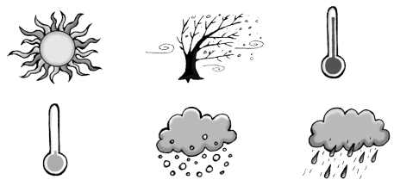

- What’s the weather like?

1 It’s snowing . | 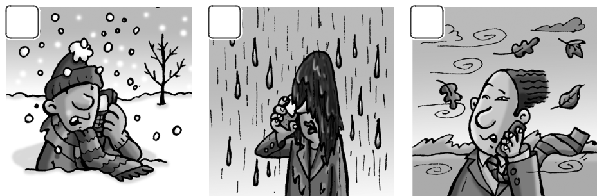  1  1 | 2 | 3

2 .

3 .

4 | .
5 | . | 4 | 5 | 6
6 | .

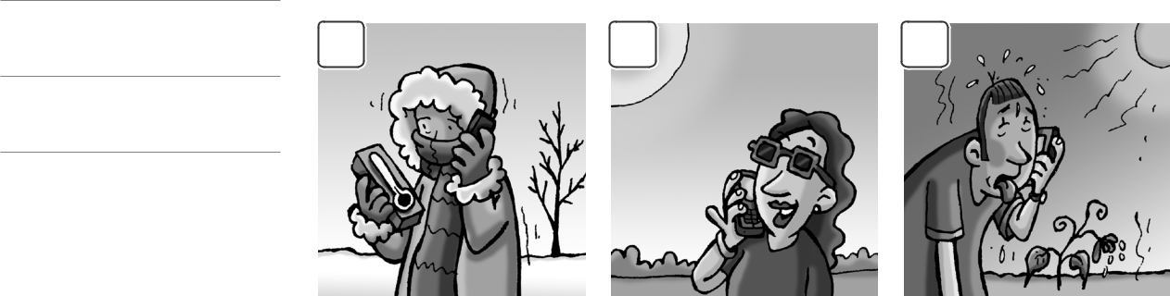

- Look and write.

Open | Close | Put on | Don’t forget | Eat Don’t put on
1 | 2 | 3 | 4 | 5 | 6
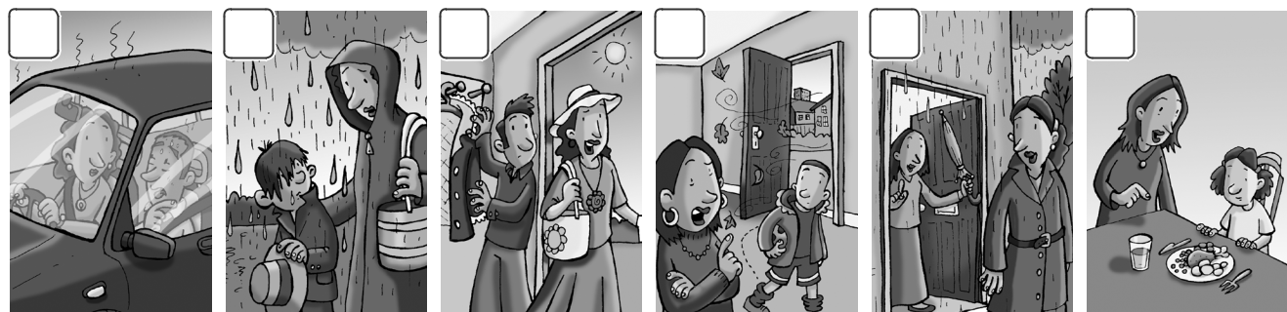

- Open the window. 2. _____________________ your hat.
- _____________________ your coat. 4. _____________________ the door.
5. _____________________ your umbrella. 6. _____________________ your dinner.
IV. Look at the picture. Circle A, B, or C.



Example (A) It’s snowing.
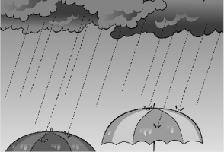
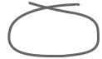

    - It’s raining.

    - It’s sunny.

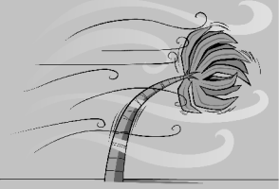
- (A) It’s windy.

  - It’s cold.

  - It’s hot.

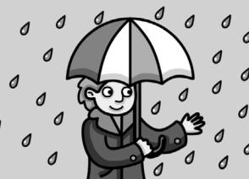
- (A) It’s sunny today. Let’s go to the park.

  - It’s snowing. Let’s make a snowman.

  - It’s raining. I have my umbrella.

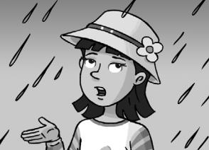

- (A) Put on your hat!

  - Don’t put on your hat!

  - Don’t forget your umbrella!

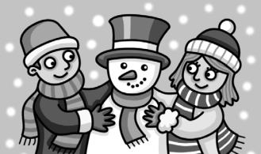
- (A) It’s hot today. Let’s go to the park and have an ice cream.

(B) It’s windy today. Let’s fly my kite.

- It’s snowing today. Let’s make a snowman.

V. Circle the correct words

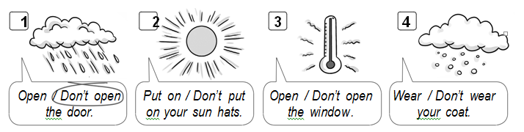

VI. Match.
1 | - Don’t close | a. go home.
2 | - Put on | b. outside.
3 | - Don’t go | c. your kite.
4 | - Don’t fly | d. the door.
5 | - Let’s make | e. a snowman.
6 | - Let’s | f. your hat.

